
ACTIVE LEARNING TEMPLATE: Growth and Development

STUDENT NAME

DEVELOPMENTAL STAGE TODDLER REVIEW MODULE CHAPTER

EXPECTED GROWTH AND DEVELOPMENT


 |  |  |  |  |  | Psychological |  |  |  | Age- Appropriate
Physical |  |  | Cognitive
Physical |  |  | Cognitive |  |  | Development |  |  |  | Activities
Development |  |  | Development |  |  | Development |  |  |  | Activities
 |  |  |  |  |  | The toddler develops
Toddler tend to gain |  |  | Increased imagination |  |  |  |  |  |  | The appropriate
 |  |  |  |  |  | strong bond with
3-5 pounds and |  |  | during play time and |  |  |  |  |  |  | activity involves
 |  |  |  |  |  | loved ones between |  |  |  | walking with toddler,
grow3-5 inches |  |  | the toddler recognizes
 |  |  |  |  |  | 12- |  |  |  | Playing hide and seek
between ages one |  |  | familiar people and |  |  | 12-
 |  |  |  |  |  | 24months.Between 2- |  |  |  | and anything that will
and two. The rapid |  |  | objects. The ability to
 |  |  |  |  |  | 4 children begin |  |  |  | encourage the
growth slows |  |  | think and understand
 |  |  |  |  |  | making choices from |  |  |  | toddlers movement is
between ages 2 and 5 |  |  | Grows (Snider, 2007).
 |  |  |  |  |  | the ages 2-5 children |  |  |  | recommended to
while they develop in
 |  |  |  |  |  | learn to love others. |  |  |  | enhance coordination
strength and
 |  |  |  |  |  |  |  |  |  | in movement.
coordination.
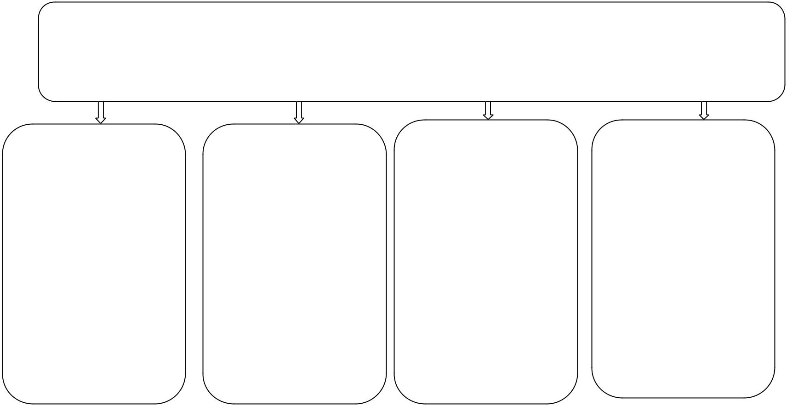

Health promotion

The indicator of problems may include crying, diaper rush, fever, high temperature Seborrhea and gastrointestinal dermatitis. Most of the problems require clinical care (Snider, 2007).

 |  |  |  | Nutrition |  | Injury Prevention
Immunizations |  | Health Screening
Immunizations |  | Health Screening |  | Regular meals and |  | Keeps everything
 |  | The screening
Toddler should |  | involves vision and |  | snacks are |  | that is dangerous out
immunize according |  | additional test which |  | appropriate. |  | of reach of a
to CDC schedule. |  | should include |  | Recommended |  | toddlers. Toddlers
The main vaccines |  | pneumonia |  | portion size is a |  | tend to keep
include varicela, |  | tuberculosis and |  | quarter of adult’s |  | everything in their
diphtheria, Pertusis |  | cholesterol. The |  | portion. The food |  | mouth. Blunt object
and whooping cough |  | regular blood |  | should be in simple |  | should not be found
vaccine among |  | pressure monitored if |  | form Checked |  | in toddler playing
others Health |  | regular at 3 years |  | portion sizes. |  | Zone (Snider, 2007).
screening. |  | Toddler.

ACTIVE LEARNING TEMPLATES THERAPEUTIC PROCEDURE A5

